Weekly assignments:

- If you don’t have a google account, you will need to create one using your school email. Once you have a google account, go to your google drive.

- Create a Folder in your Google Drive called Computer Applications and share it with me: bowersr@gcssd.org. Make sure the folder is editable by me.
- Create the following sub-folders within Computer Applications
  - Keyboarding
  - Word
  - Excel
  - PowerPoint
  - Images
- Create an Excel spreadsheet to record your keyboarding results:
  - Open Excel and do the following:
1 | In Cell A-1 type your name
2 | In Cell A-2 type Computer Applications
3 | In Cell A-3 type your block
4 | In Cell A-4 type Keyboarding Statistics
5 | In Cell A-6 type Date
6 | In Cell B-6 type Lesson
7 | In Cell C-6 type # Of Errors
8 | In Cell D-6 type WPM
9 | Name the spreadsheet Keyboarding Statistics
  - Be sure to save the spreadsheet!

- Keyboarding: Keyboarding (typing) is an important skill for your future. We will be working on increasing your keyboarding efficiency in this class.
  - Please read: Keyboarding Efficiency
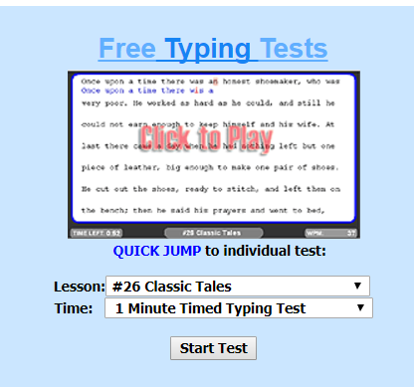
  - Take your first keyboarding test! Go to the Keyboarding Website. Click the “Free Typing Tests” link shown below:
  - Choose Lesson #26 Classic Tales.
  - Choose a Time of 3 minutes.
  - Type the story. At the end of 3 minutes it will display your words per minute. Write this number down so you won’t forget it. Go to your Excel spreadsheet you just created and enter your information from your typing test. We are going to try to improve on that number!

- Create a Haiku deck. Haiku decks are like PowerPoint presentations with very few words. You really have to focus on the message you are trying to convey and choose your words and pictures carefully.

- Blog Entries: (Use proper grammar, spelling, and punctuation!)

  - Watch: Did You Know? Make a blog post. This can be a freeform blog post that discusses anything about the video. For example you could write about how the video made you feel, what facts from the video surprised you, or what point do you think the video is trying to make. (100 words or more)

  - Please read the following article: Do Smartphones Have a Place in the Classroom? Make a blog entry in paragraph form that answers this question in 100 words or more:
What do you think the ground rules should be in our class for the use of mobile devices?
  - Read: Millennials and Office Technology? Not Such a Good Match. Make a journal entry that answers this question(100 words or more):
Do you think we are tech savvy or tech entertainment savvy? Why or Why Not? Use evidence from the article.

- Bookwork: Read pages 128-130 about Writing Business Letters
    - Complete assignments 1-11 starting on page 130

- Daily Keyboard lesson: Go to the keyboarding site. Be sure you are on the “Lessons” tab. Complete 3-5 different “lessons” that are 2-3 minutes long each so that you have practiced typing for at least 10 minutes.

