Law of Superposition Webquest
Name: _____________________ Date:_______________________Block: ____

USE THE FOLLOWING WEBSITE TO ANSWER THE FOLLOWING QUESTIONS:
http://clarkscience8.weebly.com/law-of-superposition--index-fossils.html

- What is relative age?

- Do relative age give the exact age of an object?

- What are the 2 ways relative age of rocks and fossils can be determined?

- Scientist read the rock layers knowing what?

- What does the law of superposition state?

- Define the law of superposition using your own words.

- When can relative dating be used?

- What can index fossils be used for?

- List the 5 things that qualify a fossil as being an index fossil.

- Fossils are found in many rock layers. What type of rock layers or strata do you think fossils are found in?

- What does the saying mean in the picture when it says, “…so the deeper we dig, the farther back in time we see.”

- Under the Rock Layer topic, restate what the Law of Superposition state.

- Based on what the law of superposition states, list the layers from younger to older.

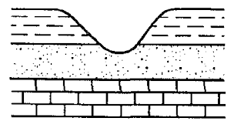
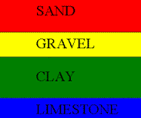
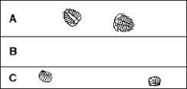

- Name 2 differences between relative and absolute dating.

- Give an example of relative and absolute dating?

- Based on your knowledge of absolute and relative age dating, what is the relative and absolute ages from the picture below?
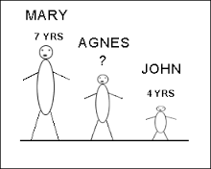 | Relative Ages:  Absolute Ages:
- What is an index fossil?

- What is a good example of index fossils during the Paleozoic Era?

- Complete the Chart below.
 | Younger Index Fossils during the time frame | Older Index Fossils during the time frame
Precambrian Time
Paleozoic Era
Mesozoic Era
Cenozoic Era

