Have your DNA and eat it too!
Making DNA models can be informative, fun, and in this case tasty. Here you will learn how to construct a DNA model using candy. But first, what is DNA? DNA, like RNA, is a nucleic acid that contains the genetic information for the reproduction of life. Its shape is that of a double helix and its appearance is somewhat of a twisted ladder or spiral staircase. DNA is composed of nitrogenous bases (adenine, cytosine, guanine and thymine), a five-carbon sugar (deoxyribose), and a phosphate molecule.
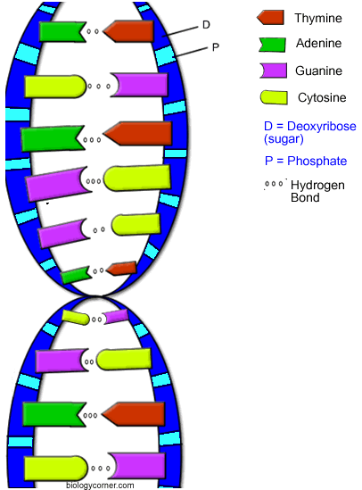
What You Need:
- Red and black licorice sticks
- Colored marshmallows or gummy bears
- Toothpicks
- Needle
- String
- Scissors
Procedure:
- Gather together red and black licorice sticks, colored marshmallows or gummy bears, toothpicks, needle, string, and scissors.
- Assign names to the colored marshmallows or gummy bears to represent nucleotide bases. There should be four different colors each representing either adenine, cytosine, guanine or thymine.
- Assign names to the colored licorice pieces with one color representing the sugar molecule and the other representing the phosphate molecule.
- Use the scissors to cut the licorice into 1 inch pieces.
- Using the needle, string half of the licorice pieces together lengthwise; alternating between the black and red pieces.
- Repeat the procedure for the remaining licorice pieces to create a total of two strands of equal length. Tie off the string so that the black and red pieces fit tightly together and will not slide off.
- Connect two different colored marshmallows or gummy bears together using the toothpicks.
- Connect the toothpicks with the candy to either the red licorice segments only or the black licorice segments only, so that the candy pieces are between the two strands.
- Holding the ends of the licorice sticks, twist the structure slightly.
- Create a key to explain what each type of candy represents. (Include Adenine, Thymine, Guanine, Cytosine, hydrogen bond, phosphate)
- Get Mrs. Bowers to view your DNA model and then you can eat it!

