Name_______________________________ Period _____________ Date ____________

Cell Organelle Web Quest

Objective: Upon completion of this activity, you should be able to describe the cell and identify its parts (organelles). You should be able to distinguish between plant and animal cells.

PART I

Go to: www.wisc-online.com/objects/index_tj.asp?objid=AP11604
Click “Next” to begin the activity. Answer the following questions.

- What is an organelle?

- What do ribosomes do?

- What do they look like?

- What does the Golgi apparatus (or Golgi bodies) do?

- What is the function of the mitochondria?

- What does the nuclear membrane do?

- What is the function of the nucleus?

- What is the cell Membrane?

PART II

Go to the interactive cell models at www.cellsalive.com/cells/3dcell.htm .

- What is the difference between smooth and rough endoplasmic reticulum (ER)?

- Where is the nucleus found?

- What is the function of a lysosome?

- What makes plant cells green?

- What does a vacuole do?

- What is the purpose of the cell wall? What type of cell is it found in?

- What is a chloroplast?

- What is the purpose of a cell? http://www.ehow.com/facts_5439557_purpose-cell.html

- What are the two types of reproduction and explain?

http://www.biotopics.co.uk/genes1/asexual_and_sexual_reproduction.html

- ______________________ -

- ______________________ -

Name_______________________________ Period _____________ Date ____________

18. NOW USE THE PROVIDED WEBSITE LINKS TO HELP YOU LABEL YOUR CELL DIAGRAMS. DON’T FORGET TO DO BOTH THE PLANT AND THE ANIMAL CELL!!!
Animal Cell Coloring

Use the following link to assist you: http://www.enchantedlearning.com/subjects/animals/cell/

Cell Membrane (light brown) | Nucleolus (black) | Mitochondria (orange)
Cytoplasm (white) | Golgi Apparatus (pink) | Lysosome (purple)
Ribosome (red) | Cilia (yellow) | Smooth Endoplasmic Reticulum( light blue)
Nuclear Membrane (dark brown) | Rough Endoplasmic Reticulum (dark blue)
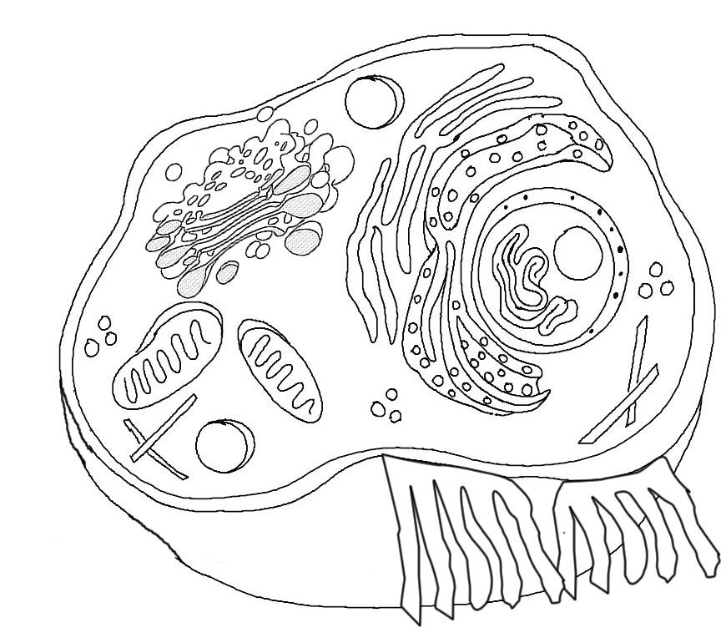

II. Briefly describe the function of the cell parts.

- Cell membrane ____________________________________________________________________

- Endoplasmic Reticulum ______________________________________________________________

- Ribosome ________________________________________________________________________

- Golgi Apparatus ___________________________________________________________________

- Lysosome ________________________________________________________________________

- Microtubule _______________________________________________________________________

- Mitochondria ______________________________________________________________________

- Nucleus __________________________________________________________________________

Name_______________________________ Period _____________ Date ____________

Plant Cell Coloring

Use the following link to assist you: http://www.enchantedlearning.com/subjects/plants/cell/

Cell Membrane (orange) | Cell Wall (dark green) | Ribosome (purple)
 | Nucleolus (brown) | Cytoplasm (white)
Mitochondria (red)
 | Chloroplasts (light green) | Golgi Apparatus (dk blue)
Vacuole (light blue)
Smooth Endoplasmic Reticulum (pink)

Chromosomes (gray)
Rough Endoplasmic Reticulum (pink)
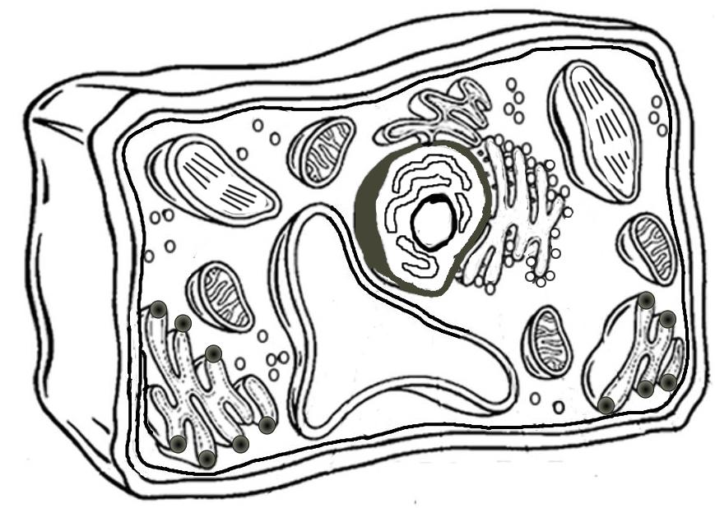

Analysis

- Name two things found in a plant cell that are not found in an animal cell:

- How does the shape of a plant cell differ from that of an animal cell?

- What is the function of the chloroplasts?

- What is the function of the vacuole?

Name_______________________________ Period _____________ Date ____________

PART III

Cell Quiz: Go to https://www.biologycorner.com//quiz/qz_cell.html. Complete the cell quiz. When you are finished, raise your hand to show your score to your teacher.
Score _________ Teacher’s s initials ________________

PART IV

Finished with time to spare? Go back to www.cellsalive.com/cells/3dcell.htm . Click on PUZZLES on the left hand side of the screen and complete a cell puzzle.

You may also try a review game:

Battleship: www.quia.com/ba/15335.html

Matching: www.quia.com/mc/310905.html

